PRINCIPAL COMPONENT ANALYSIS
Complete Trainee Notes with Full Numerical Calculation
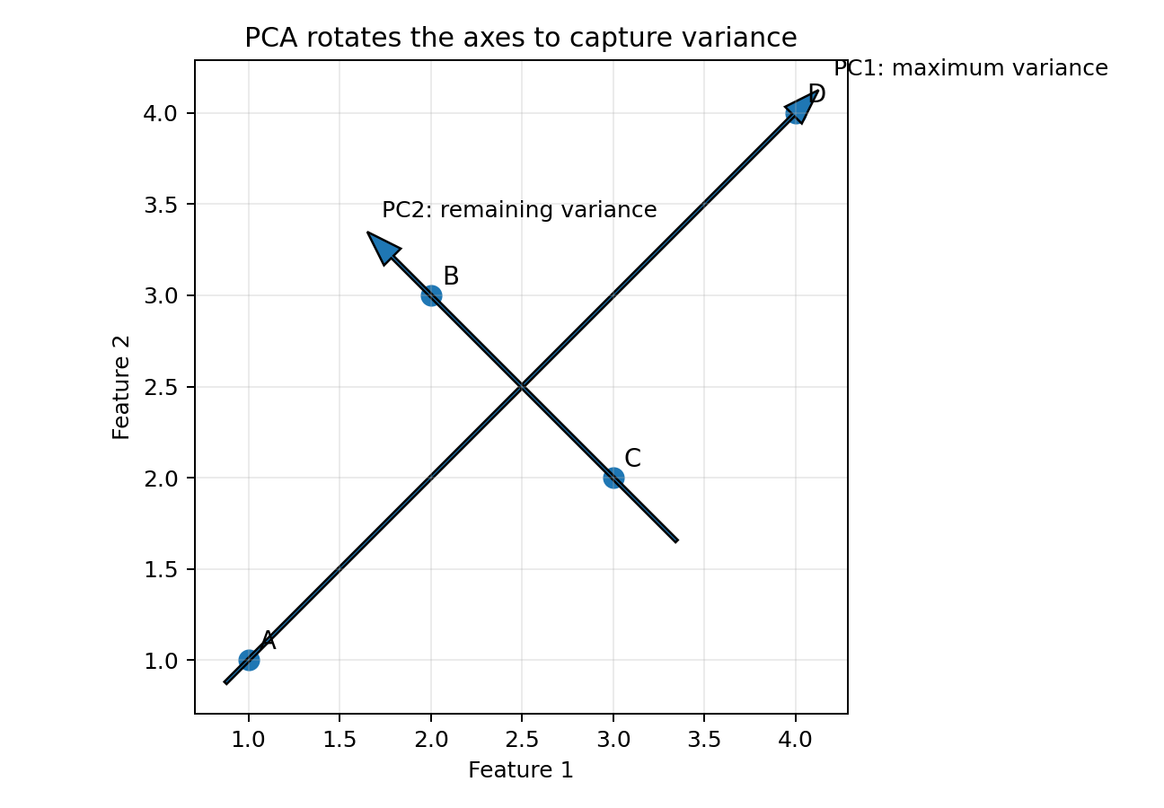
PCA rotates the original axes and finds directions that capture the maximum variance.
Includes concepts, formulas, Excel steps, Python hands-on, FAQs, quiz and answers

Contents
1. Why do we need dimensionality reduction?
2. What is PCA?
3. PCA intuition and terminology
4. When to use PCA and when not to use it
5. Data preparation before PCA
6. PCA workflow
7. Complete numerical example with formulas and Excel steps
8. General PCA formulas
9. Explained variance and selecting components
10. Loadings, scores and interpretation
11. Maximum number of components
12. PCA versus feature selection and LDA
13. Assumptions, limitations and common mistakes
14. Python hands-on
15. Excel formula cheat sheet
16. FAQs, revision quiz and answers
17. Glossary

1. Why Do We Need Dimensionality Reduction?
A dimension is an input feature or column used by a machine-learning model. A dataset with 100 input columns has 100 dimensions.
Simple example
A customer dataset may contain annual income, monthly income, account balance, average balance, total spending and credit limit. Several of these variables may carry overlapping information.

When the number of features becomes large, we may face the following problems:
- More computation time and memory usage.
- Difficulty visualizing the data.
- Multicollinearity: several features contain similar information.
- Noise and irrelevant variation can make learning harder.
- Distance-based models may perform poorly in very high dimensions, a problem called the curse of dimensionality.
- The model may become more complex without gaining useful information.
Dimensionality reduction
Dimensionality reduction represents the original data using fewer dimensions while trying to preserve the most useful information.

Two broad approaches
Approach | What it does | Example
Feature selection | Keeps some original columns and removes others. | Keep income and total spending; drop monthly income.
Feature extraction | Creates new columns by combining original columns. | PCA creates PC1, PC2 and so on.

PCA is a feature-extraction method. It does not simply select the best original columns; it creates new components.

2. What Is PCA?
Definition
Principal Component Analysis (PCA) is an unsupervised linear technique that converts correlated numerical features into a new set of uncorrelated directions called principal components.

- PC1 captures the maximum possible variance in the data.
- PC2 captures the maximum remaining variance while staying perpendicular to PC1.
- PC3 captures the maximum variance remaining after PC1 and PC2, and so on.
- The components are ordered from most variance to least variance.
- The target variable is not used to create the components.
Original features -> Principal components
PCA changes the coordinate system. The rows remain the same, but their coordinates are expressed using new axes.


Figure 1. PC1 follows the direction with the largest spread; PC2 is perpendicular and captures the remaining spread.

A simple real-life analogy
Imagine taking several photographs of a long pencil. One angle shows the pencil almost as a dot, while another angle shows its full length. PCA tries to find the viewing direction that reveals the largest amount of variation first.
Easy memory sentence
Eigenvector tells PCA where to look. Eigenvalue tells PCA how much information is present in that direction.

3. PCA Intuition and Important Terminology
Term | Simple meaning
Feature / dimension | An original input column, such as height, weight or salary.
Variance | How widely the values of one feature are spread around their mean.
Covariance | Whether two features tend to increase or decrease together.
Covariance matrix | A table containing feature variances and pairwise covariances.
Principal component | A new feature formed as a weighted combination of original features.
Eigenvector | The direction of a principal component. Its entries become component coefficients.
Eigenvalue | The variance captured along the corresponding eigenvector direction.
Coefficient / component weight | The multiplier applied to an original feature in a component equation.
Loading | A measure of how strongly an original feature contributes to a component. Terminology varies; scikit-learn components_ contains the eigenvector coefficients.
PC score | A row's coordinate on a principal component after projection.
Explained variance ratio | The proportion of total variance captured by a component.
Projection | Placing a point onto a new component direction to calculate its score.

Principal-component equation
PC1 = a1 X1 + a2 X2 + ... + ap Xp
X1 to Xp are centred or standardized features. a1 to ap are the eigenvector coefficients.

The coefficients do not normally add to 1. The eigenvector is usually normalized so that the squares of its coefficients add to 1.
a1^2 + a2^2 + ... + ap^2 = 1

4. When to Use PCA and When Not to Use It

Good situations for PCA
- Many numerical input features are available.
- Several features are strongly correlated.
- You need a two-dimensional or three-dimensional visualization.
- You want compression or noise reduction.
- You want to reduce computation before another model.
- You are willing to trade some interpretability for a smaller representation.

Situations where PCA may not be suitable
- The original feature meanings must remain directly interpretable.
- The relationship in the data is strongly nonlinear; Kernel PCA or another nonlinear method may be more suitable.
- The high-variance directions are not useful for the prediction target. PCA does not use the target label.
- The dataset contains severe outliers that have not been handled.
- The input consists mainly of IDs, codes or raw categorical labels.
- There are only a few features and dimensionality is not causing a problem.
Important
PCA may improve speed or reduce noise, but it does not guarantee better model accuracy. Always compare the model before and after PCA.

5. Data Preparation Before PCA
1. Keep numerical input features only. Remove identifiers such as customer ID.
2. Handle missing values because standard PCA cannot directly process missing data.
3. Inspect and treat severe outliers because PCA is sensitive to extreme values.
4. Decide whether scaling is needed.
5. Split data into training and test sets before fitting the scaler or PCA in a predictive modelling workflow.
6. Fit preprocessing only on training data and use the fitted objects to transform validation and test data.

Why scaling matters
PCA looks for variance. A feature measured on a numerically larger scale can dominate even when it is not more important.
Feature | Typical values | Problem without scaling
Age | 18 to 70 years | Variance is relatively small.
Annual salary | 300,000 to 3,000,000 rupees | Variance is extremely large and may dominate PCA.
Satisfaction score | 1 to 5 | May contribute almost nothing compared with salary.

z = (x - mean) / standard deviation
Standardization creates a mean of approximately 0 and a standard deviation of approximately 1 for each feature.

When scaling may be skipped
If all features use the same unit and comparable scale, covariance-based PCA may be meaningful without standardization. In the classroom numerical example, both columns are marks out of 100, so we first show covariance-based PCA directly.

6. PCA Workflow
Step | Action | Purpose
1 | Prepare data | Select numerical features; handle missing values and outliers.
2 | Centre or standardize | Subtract means; usually standardize when units or scales differ.
3 | Build covariance/correlation matrix | Summarize variances and relationships among features.
4 | Find eigenvalues and eigenvectors | Eigenvectors give directions; eigenvalues give variance along those directions.
5 | Sort components | Arrange components from highest eigenvalue to lowest.
6 | Choose number of components | Use explained variance, a scree plot and model performance.
7 | Project the data | Multiply centred/standardized data by selected eigenvectors.
8 | Use and evaluate | Visualize, compress, or train a model and compare results.

7. Complete Numerical Example: PCA by Hand and in Excel
Dataset
Four students have Math and Science marks. The two features use the same unit and scale, so we will use the covariance matrix without standardizing. This keeps the first explanation simple.

Step 1 - Enter the original data
Student | Math | Science
A | 40 | 40
B | 50 | 60
C | 60 | 50
D | 70 | 70

Say this
We have four rows and two original features. PCA can create at most two principal-component directions for this example.

Step 2 - Calculate the mean of each feature
Mean = sum of values / number of values

Math mean = (40 + 50 + 60 + 70) / 4 = 55

Science mean = (40 + 60 + 50 + 70) / 4 = 55

Excel cell | Formula | Result
B7 | =AVERAGE(B2:B5) | 55
C7 | =AVERAGE(C2:C5) | 55

Step 3 - Centre the data
Centring means subtracting the feature mean from every value.
Centred value = original value - feature mean

Student | Math | Science | Math centred | Science centred
A | 40 | 40 | -15 | -15
B | 50 | 60 | -5 | 5
C | 60 | 50 | 5 | -5
D | 70 | 70 | 15 | 15

Excel cell | Formula | Action
D2 | =B2-$B$7 | Drag down to D5
E2 | =C2-$C$7 | Drag down to E5

Interpretation
Zero now represents the average. Negative values are below the mean; positive values are above the mean.

Step 4 - Calculate variance
Variance measures spread. We use sample variance, so we divide by n - 1.
Sample variance = sum of squared deviations / (n - 1)

For Math, the centred values are -15, -5, 5 and 15.
(-15)^2 + (-5)^2 + 5^2 + 15^2 = 225 + 25 + 25 + 225 = 500

Math variance = 500 / (4 - 1) = 166.67

Science has the same centred values in a different order, so its variance is also 166.67.
Excel formula | Result
=VAR.S(D2:D5) | 166.67
=VAR.S(E2:E5) | 166.67

Step 5 - Calculate covariance
Covariance tells us whether two features tend to move together.
Sample covariance = sum[(Math centred)(Science centred)] / (n - 1)

Student | Math centred | Science centred | Product
A | -15 | -15 | 225
B | -5 | 5 | -25
C | 5 | -5 | -25
D | 15 | 15 | 225

Covariance = (225 - 25 - 25 + 225) / 3 = 400 / 3 = 133.33

Excel formula | Result
=COVARIANCE.S(D2:D5,E2:E5) | 133.33

Interpretation
The covariance is positive. In general, higher Math marks occur with higher Science marks in this small dataset.

Step 6 - Build the covariance matrix C
C = [[Variance(Math), Covariance], [Covariance, Variance(Science)]]

C = [[166.67, 133.33], [133.33, 166.67]]

 | Math | Science
Math | 166.67 | 133.33
Science | 133.33 | 166.67

What the matrix shows
Diagonal entries are feature variances. Off-diagonal entries are covariances. The matrix is symmetric.

Step 7 - Find eigenvalues
Eigenvalues tell us the variance captured in each principal-component direction.
|C - lambda I| = 0
C is the covariance matrix, lambda is an unknown eigenvalue, I is the identity matrix, and the vertical bars mean determinant.

I = [[1, 0], [0, 1]]

C - lambda I = [[166.67 - lambda, 133.33], [133.33, 166.67 - lambda]]

For a 2 x 2 matrix [[a,b],[c,d]], the determinant is ad - bc.
(166.67 - lambda)^2 - (133.33)^2 = 0

(166.67 - lambda)^2 = (133.33)^2

166.67 - lambda = +/- 133.33

This produces two eigenvalues:
lambda1 = 166.67 + 133.33 = 300

lambda2 = 166.67 - 133.33 = 33.33

Simple interpretation
The first direction has variance 300. The second direction has variance 33.33. Therefore, the first direction is much more important.

Step 8 - Find the eigenvector for PC1
An eigenvector contains one coefficient for each original feature. Because we have two features, write:
v = [x, y]^T

x is the Math coefficient and y is the Science coefficient. Start with:
(C - lambda I)v = 0

For PC1, substitute lambda1 = 300:
[[166.67 - 300, 133.33], [133.33, 166.67 - 300]] [x, y]^T = [0,0]^T

The first row gives:
-133.33x + 133.33y = 0

-x + y = 0 -> y = x

The two coefficients must be equal. Choose the simplest direction [1,1]. Any multiple such as [2,2] points in the same direction.
Normalize the vector so that its length is 1:
Length = sqrt(1^2 + 1^2) = sqrt(2) = 1.4142

1 / sqrt(2) = 0.7071

PC1 eigenvector = [0.7071, 0.7071]^T

Where did 0.7071 come from?
It was calculated by dividing [1,1] by its length sqrt(2). It was not selected manually.

Step 9 - Find the eigenvector for PC2
For PC2, substitute lambda2 = 33.33:
133.33x + 133.33y = 0

x + y = 0 -> y = -x

The two coefficients must be opposite. Choose the simplest direction [1,-1] and normalize it.
PC2 eigenvector = [0.7071, -0.7071]^T

Why are PC1 and PC2 perpendicular?
Their dot product is 0: (0.7071 x 0.7071) + (0.7071 x -0.7071) = 0. Perpendicular component directions do not overlap.

Step 10 - Write the principal-component equations
PC1 = 0.7071(Math centred) + 0.7071(Science centred)

PC2 = 0.7071(Math centred) - 0.7071(Science centred)

Meaning of the equations
PC1 adds Math and Science and represents overall performance. PC2 compares Math with Science and represents relative strength in one subject versus the other.

The coefficients do not have to add to 1: 0.7071 + 0.7071 = 1.4142. Their squares add to 1: 0.7071^2 + 0.7071^2 = 1.

Step 11 - Calculate the PC scores
Each student receives a new coordinate on PC1 and PC2.
PC score = centred row dot eigenvector

For Student A, Math centred = -15 and Science centred = -15:
PC1 = 0.7071(-15) + 0.7071(-15) = -21.213

PC2 = 0.7071(-15) - 0.7071(-15) = 0

Student | Math centred | Science centred | PC1 score | PC2 score
A | -15 | -15 | -21.213 | 0.000
B | -5 | 5 | 0.000 | -7.071
C | 5 | -5 | 0.000 | 7.071
D | 15 | 15 | 21.213 | 0.000

Excel cell | Formula | Action
F2 | =D2*$L$7+E2*$M$7 | Drag down
G2 | =D2*$L$8+E2*$M$8 | Drag down

Step 12 - Calculate explained variance
Explained variance ratio of PCi = eigenvalue_i / sum of all eigenvalues

Total variance = 300 + 33.33 = 333.33

PC1 ratio = 300 / 333.33 = 0.90 = 90%

PC2 ratio = 33.33 / 333.33 = 0.10 = 10%

Component | Eigenvalue | Explained variance
PC1 | 300.00 | 90%
PC2 | 33.33 | 10%

Decision
Keeping both components retains 100% of the variance. Keeping only PC1 reduces two features to one while retaining 90% of the variance.

Step 13 - Verify that eigenvalue equals PC-score variance
The PC1 scores are -21.213, 0, 0 and 21.213. Their sample variance is 300, exactly equal to the PC1 eigenvalue.
=VAR.S(PC1 score range) -> 300

The PC2-score sample variance is 33.33, exactly equal to the PC2 eigenvalue.
=VAR.S(PC2 score range) -> 33.33

Core fact
The eigenvalue of a principal component is the variance of the data after projection onto that component.

Step 14 - Final interpretation of the example
- PC1 is an overall-score direction because Math and Science have equal positive coefficients.
- Student D has the highest PC1 score, meaning high overall performance.
- Student A has the lowest PC1 score, meaning low overall performance.
- PC2 compares Math with Science because one coefficient is positive and the other is negative.
- Student C has positive PC2 because Math is higher than Science.
- Student B has negative PC2 because Science is higher than Math.
- PC1 and PC2 are uncorrelated in the transformed sample.

The same example after standardization
If the two features are standardized first, their covariance matrix becomes their correlation matrix:
R = [[1, 0.8], [0.8, 1]]

The eigenvalues become 1.8 and 0.2, but the explained-variance percentages remain 90% and 10%, and the eigenvectors remain [0.7071,0.7071] and [0.7071,-0.7071].

8. General PCA Formulas

Centre the data
X_centered = X - column means

Standardize when required
z_ij = (x_ij - mean_j) / standard_deviation_j

Covariance matrix
C = (1 / (n - 1)) X_centered^T X_centered

Eigenvalue equation
C v_i = lambda_i v_i

(C - lambda_i I)v_i = 0

|C - lambda I| = 0

Project the data
Z = X_centered W

W contains the selected eigenvectors as columns. Z contains the principal-component scores.

Explained variance
Explained variance ratio_i = lambda_i / sum(lambda_j)

Cumulative explained variance
Cumulative ratio_k = ratio_1 + ratio_2 + ... + ratio_k

Reconstruction from selected components
X_reconstructed = Z W^T + column means

If all components are retained, reconstruction is exact apart from numerical rounding. If some components are removed, reconstruction is approximate.

9. Explained Variance and Selecting Components
A component with a large eigenvalue captures more variance. Components are sorted from the largest eigenvalue to the smallest.

Common ways to select n_components
- Keep enough components to retain a chosen threshold such as 90%, 95% or 99% cumulative variance.
- Inspect a scree plot and look for an elbow where additional components provide small gains.
- Choose the number that gives the best validation performance for the downstream task.
- Use two or three components when visualization is the main purpose, while clearly reporting the variance retained.
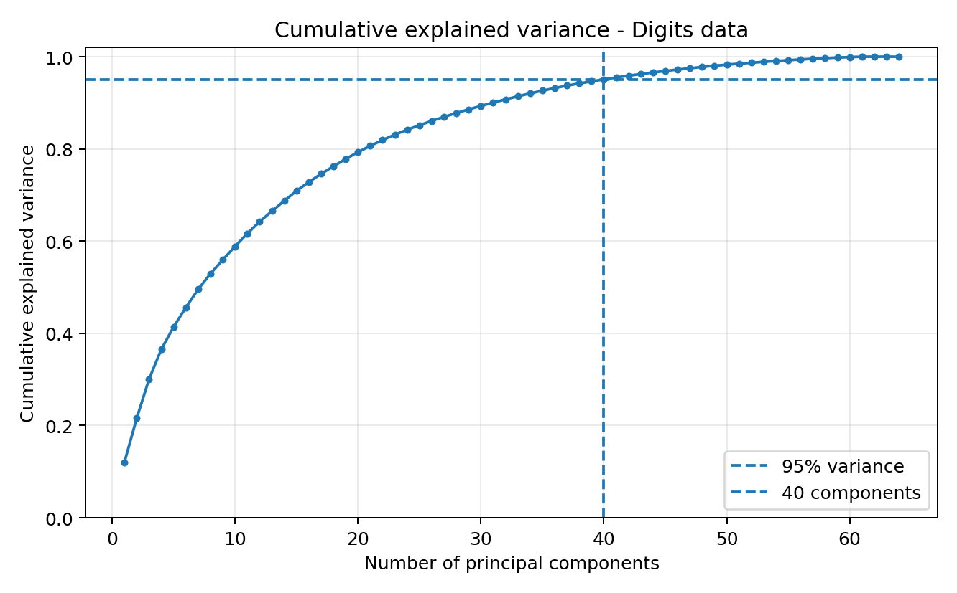
Figure 2. Cumulative explained variance for the digits dataset. About 40 components retain roughly 95% of the variance.
Do not use a threshold blindly
A 95% threshold is a common starting point, not a universal rule. Consider the business objective, model accuracy, speed and interpretability.

Scree plot versus cumulative plot
Plot | Y-axis | How it is used
Scree plot | Individual explained variance or eigenvalue | Look for a sharp bend or elbow.
Cumulative explained variance plot | Running total of explained variance | Find the first component count reaching the desired threshold.

10. Loadings, Component Coefficients and Scores

Component coefficients
The entries of an eigenvector show the direction of a principal component. In scikit-learn, they appear in pca.components_.
PC1 = 0.65 X1 + 0.62 X2 - 0.31 X3 + ...

- A large absolute coefficient means the feature strongly influences the component direction.
- A positive sign means the feature increases with the component score.
- A negative sign means the feature moves in the opposite direction.
- The sign can flip for the entire eigenvector without changing the PCA solution.

PC scores
A PC score belongs to a row, not a feature. It tells where that row lies along the component direction.
Object | Belongs to | Meaning
Coefficient / eigenvector entry | Feature | How the feature contributes to the component.
PC score | Row / observation | The row's new coordinate on the component.
Eigenvalue | Component | Variance captured by the component.

Can the same original feature appear in PC1 and PC2?
Yes. A feature can contribute to several components with different coefficients. However, PC1 and PC2 directions are orthogonal, and their scores are uncorrelated in the fitted sample.
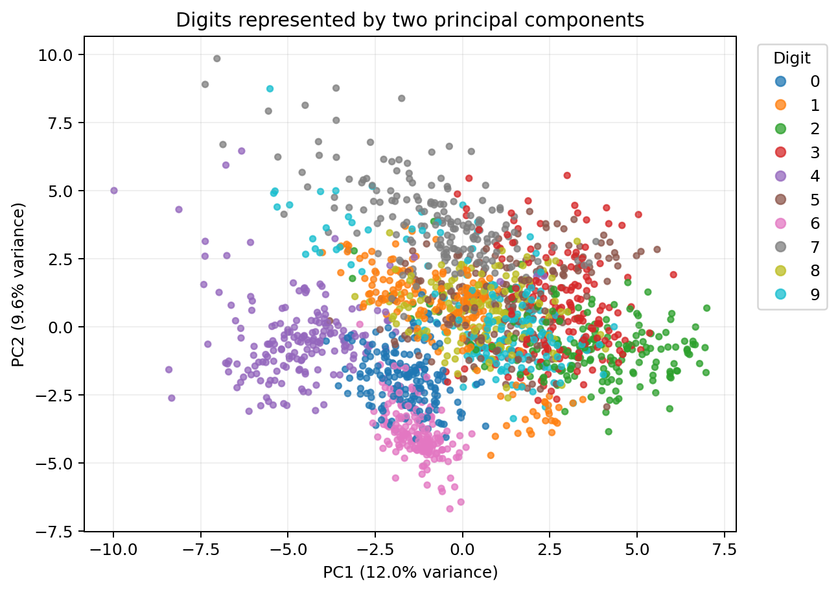
Figure 3. Digits projected onto PC1 and PC2. Classes may overlap because PCA maximizes variance and does not use class labels.

11. Maximum Number of Principal Components
Maximum components usually = number of original features p

With two input features, there can be at most two component directions. With 100 input features, there can be at most 100 component directions.
More precise rule for non-zero components
After centring, the maximum number of components with non-zero variance is at most min(number of features, number of rows - 1).

Rows n | Features p | Maximum non-zero PCs
100 | 10 | min(10,99) = 10
4 | 10 | min(10,3) = 3
1000 | 64 | min(64,999) = 64

12. PCA Compared with Other Approaches

PCA versus feature selection
Question | PCA | Feature selection
What happens to columns? | New mixed components are created. | Some original columns are retained.
Interpretability | Usually lower. | Usually higher.
Correlated features | Can combine them efficiently. | One or more may be removed.
Uses target? | No. | May or may not, depending on method.

PCA versus Linear Discriminant Analysis (LDA)
Point | PCA | Linear Discriminant Analysis
Learning type | Unsupervised | Supervised
Uses class labels? | No | Yes
Objective | Maximize total variance | Maximize class separation
Maximum useful components | Up to min(p, n-1) | Up to number of classes - 1
Class overlap | May remain | Actively tries to reduce overlap

13. Assumptions, Limitations and Common Mistakes

Practical assumptions
- The variables are numerical or have been represented numerically in a meaningful way.
- Linear combinations can represent the important structure.
- Variance is a useful measure of information for the problem.
- Observations are comparable and preprocessing is appropriate.
- Enough rows are available to estimate the covariance structure reliably.
Normality is not a strict requirement
PCA can be calculated without normally distributed features. Normality may matter for some statistical inference, but it is not required for the basic PCA transformation.

Limitations
- Components can be difficult to explain because they combine many original features.
- Dropping components causes information loss.
- PCA is sensitive to scale when features use different units.
- PCA is sensitive to outliers.
- PCA captures linear directions and may miss nonlinear structure.
- Maximum variance is not always the same as maximum predictive usefulness.
- A fitted PCA model may become less representative if the data distribution changes.

Common mistakes and corrections
Mistake | Why it is wrong | Correct action
Fitting scaler/PCA before train-test split | Information from test data leaks into training. | Split first; fit on training data only.
Assuming coefficients add to 1 | Eigenvectors are normalized by length, not by sum. | Check that squared coefficients sum to 1.
Calling PCA feature selection | PCA creates new features. | Call it feature extraction.
Using IDs in PCA | Numeric codes do not represent meaningful distance or variance. | Remove identifiers.
Skipping scaling for mixed units | Large-scale variables dominate. | Use StandardScaler or justify covariance PCA.
Assuming higher accuracy | PCA can remove predictive information. | Compare validation results before and after.
Interpreting sign as fixed | Eigenvector signs can flip. | Interpret relative patterns, not arbitrary orientation.
Using PC1 and PC2 as if they separate classes | PCA ignores labels. | Use LDA or supervised methods when separation is the goal.

14. Python Hands-On

A. PCA calculation from scratch using NumPy
import numpy as np
# Rows: students; columns: Math and Science
X = np.array([
[40, 40],
[50, 60],
[60, 50],
[70, 70]
], dtype=float)
# 1. Centre the data
mean = X.mean(axis=0)
X_centered = X - mean
# 2. Covariance matrix
cov_matrix = np.cov(X_centered, rowvar=False, ddof=1)
# 3. Eigenvalues and eigenvectors
# eigh is suitable for symmetric covariance matrices
eigenvalues, eigenvectors = np.linalg.eigh(cov_matrix)
# 4. Sort from largest eigenvalue to smallest
order = np.argsort(eigenvalues)[::-1]
eigenvalues = eigenvalues[order]
eigenvectors = eigenvectors[:, order]
# 5. Explained variance ratio
explained_ratio = eigenvalues / eigenvalues.sum()
# 6. Project rows to obtain PC scores
scores = X_centered @ eigenvectors
print('Mean:', mean)
print('Covariance matrix:
', cov_matrix)
print('Eigenvalues:', eigenvalues)
print('Eigenvectors:
', eigenvectors)
print('Explained variance ratio:', explained_ratio)
print('PC scores:
', scores)

Expected pattern
The eigenvalues should be approximately 300 and 33.33. Eigenvector signs may be the reverse of the manual answer; that is still correct because an eigenvector and its negative represent the same direction.

B. Safe scikit-learn workflow for predictive modelling
from sklearn.datasets import load_breast_cancer
from sklearn.model_selection import train_test_split
from sklearn.preprocessing import StandardScaler
from sklearn.decomposition import PCA
from sklearn.linear_model import LogisticRegression
from sklearn.pipeline import Pipeline
from sklearn.metrics import accuracy_score
X, y = load_breast_cancer(return_X_y=True)
X_train, X_test, y_train, y_test = train_test_split(
X, y,
test_size=0.20,
random_state=42,
stratify=y
)
# n_components=0.95 keeps enough PCs to retain at least 95% variance
pipeline = Pipeline([
('scaler', StandardScaler()),
('pca', PCA(n_components=0.95)),
('model', LogisticRegression(max_iter=5000))
])
pipeline.fit(X_train, y_train)
y_pred = pipeline.predict(X_test)
pca = pipeline.named_steps['pca']
print('Selected components:', pca.n_components_)
print('Cumulative variance:', pca.explained_variance_ratio_.sum())
print('Test accuracy:', accuracy_score(y_test, y_pred))

Why Pipeline is recommended
The scaler and PCA are fitted only using the training data during model fitting. This prevents leakage and makes cross-validation safer.

C. Plot cumulative explained variance
import numpy as np
import matplotlib.pyplot as plt
from sklearn.preprocessing import StandardScaler
from sklearn.decomposition import PCA
X_scaled = StandardScaler().fit_transform(X)
pca_all = PCA().fit(X_scaled)
cumulative = np.cumsum(pca_all.explained_variance_ratio_)
plt.plot(range(1, len(cumulative) + 1), cumulative, marker='o')
plt.axhline(0.95, linestyle='--')
plt.xlabel('Number of principal components')
plt.ylabel('Cumulative explained variance')
plt.title('Choosing the number of PCA components')
plt.show()

D. Two-dimensional PCA visualization
from sklearn.datasets import load_digits
from sklearn.preprocessing import StandardScaler
from sklearn.decomposition import PCA
import matplotlib.pyplot as plt
X, y = load_digits(return_X_y=True)
X_scaled = StandardScaler().fit_transform(X)
X_2d = PCA(n_components=2).fit_transform(X_scaled)
plt.scatter(X_2d[:, 0], X_2d[:, 1], c=y, s=12)
plt.xlabel('PC1')
plt.ylabel('PC2')
plt.title('Digits represented using two principal components')
plt.show()

The classes may overlap in this graph because PCA does not use the digit labels while choosing directions.

15. Excel Formula Cheat Sheet for the Numerical Example
Task | Example Excel formula
Math mean | =AVERAGE(B2:B5)
Science mean | =AVERAGE(C2:C5)
Math centred value | =B2-$B$7
Science centred value | =C2-$C$7
Math sample variance | =VAR.S(D2:D5)
Science sample variance | =VAR.S(E2:E5)
Sample covariance | =COVARIANCE.S(D2:D5,E2:E5)
Normalized coefficient | =1/SQRT(2)
PC1 score | =D2*$L$7+E2*$M$7
PC2 score | =D2*$L$8+E2*$M$8
PC1 score variance | =VAR.S(F2:F5)
Explained variance ratio | =Eigenvalue/SUM(All_Eigenvalues)

Excel limitation
Excel has no simple built-in worksheet function that directly returns eigenvalues and eigenvectors for a general covariance matrix. The manual derivation above is practical for a 2 x 2 classroom example. For larger matrices, use Python, R, MATLAB, an add-in or numerical software.

16. Frequently Asked Questions
Q. Do PCA coefficients have to add to 1?
A. No. Eigenvectors are generally normalized so that the sum of squared coefficients equals 1.
Q. Can the same feature contribute to PC1 and PC2?
A. Yes. The same original feature can appear in several components with different coefficients.
Q. Can PC1 and PC2 overlap?
A. Their directions do not overlap because they are orthogonal. However, classes or plotted points may overlap in a PC1-PC2 graph.
Q. Are PC1 and PC2 correlated?
A. The PC scores are uncorrelated in the data used to fit PCA, apart from numerical rounding.
Q. Why can an eigenvector sign be negative?
A. The sign indicates direction. Multiplying every coefficient by -1 gives the same axis in the opposite orientation.
Q. Does PCA use the target column?
A. No. Standard PCA is unsupervised and uses only X.
Q. Is standardization always necessary?
A. Not always, but it is usually recommended when features have different units or scales.
Q. What is the maximum number of components?
A. Usually the number of input features; the maximum number with non-zero variance is at most min(p, n-1) after centring.
Q. Does PCA remove multicollinearity?
A. The resulting components are uncorrelated, so they do not have the original multicollinearity.
Q. Does PCA always improve accuracy?
A. No. It may improve speed or reduce noise, but it can also remove predictive information.
Q. Can PCA be used for categorical data?
A. PCA is designed for numerical measurements. One-hot encoded data can be used cautiously, but methods such as Multiple Correspondence Analysis may be more suitable for purely categorical data.
Q. What happens when every component is retained?
A. The transformation is only a rotation/reflection of the centred data, so no variance is lost.
Q. What happens when components are removed?
A. The representation becomes smaller, but some variance and reconstruction detail are lost.
Q. Are principal components independent?
A. They are uncorrelated, but uncorrelated does not always mean statistically independent.

Revision Quiz
1. PCA is supervised or unsupervised?
2. What does an eigenvector represent?
3. What does an eigenvalue represent?
4. Why is scaling usually performed before PCA?
5. Do PCA coefficients need to add to 1?
6. If a dataset has 20 features and enough rows, what is the maximum number of PCs?
7. In the Math-Science example, what percentage does PC1 capture?
8. Why can classes overlap on a PCA graph?
9. What is the difference between a component coefficient and a PC score?
10. What leakage mistake should be avoided in predictive modelling?

Quiz Answers
1. Unsupervised.
2. A direction in feature space; its entries become component coefficients.
3. The variance captured along that direction.
4. To prevent features with larger numerical scales from dominating the variance.
5. No; their squares generally sum to 1 after normalization.
6. 20.
7. 90%.
8. PCA maximizes variance and does not use class labels.
9. A coefficient belongs to a feature and defines the direction; a score belongs to a row and gives its new coordinate.
10. Do not fit the scaler or PCA on the complete dataset before splitting. Fit them on training data only.

17. Quick Recap and Glossary
PCA in one sentence
PCA finds new perpendicular directions that capture the maximum variance, ranks those directions using eigenvalues, and projects the data onto the selected directions.

Data -> centre/scale -> covariance matrix -> eigenvalues/eigenvectors -> select PCs -> project

Glossary
Word | Meaning
Centre | Subtract the feature mean.
Standardize | Subtract the mean and divide by standard deviation.
Variance | Spread of one variable.
Covariance | Joint movement of two variables.
Eigenvector | Principal-component direction.
Eigenvalue | Variance along that direction.
Explained variance ratio | Component eigenvalue divided by total eigenvalues.
Orthogonal | Perpendicular; dot product equals zero.
Projection | Calculation of component scores from original rows.
Reconstruction | Approximation of original data from retained components.
Scree plot | Plot showing variance/eigenvalue by component.
Cumulative variance | Running total of variance retained by the first k components.

Final classroom summary
1. PCA does not delete rows; it changes the feature axes.
2. The eigenvector gives the component equation.
3. The eigenvalue tells how much variance the component captures.
4. PC1 captures the most variance; each later PC captures less remaining variance.
5. Explained variance helps decide how many components to retain.
6. Scaling, leakage prevention and validation are essential in practical modelling.
.

